CN Lab Report – Week 7

PES1201800366

Aditeya Baral

**1. Task 1**

**1.1 Configuring Topology**

* The network devices are organised in the required topology shown.
* IP Addresses have been assigned to each interface being used on the routers and end systems.
* The routing tables are then configured manually by adding the required routing information.
* The two servers in the topology correspond to a DNS Server that serves DNS queries from the PC and a web server that serves webpages stored on it. The server is appropriately configured as well.
* An HTTP request is made from the PC for the page index.html in the domain google.com.

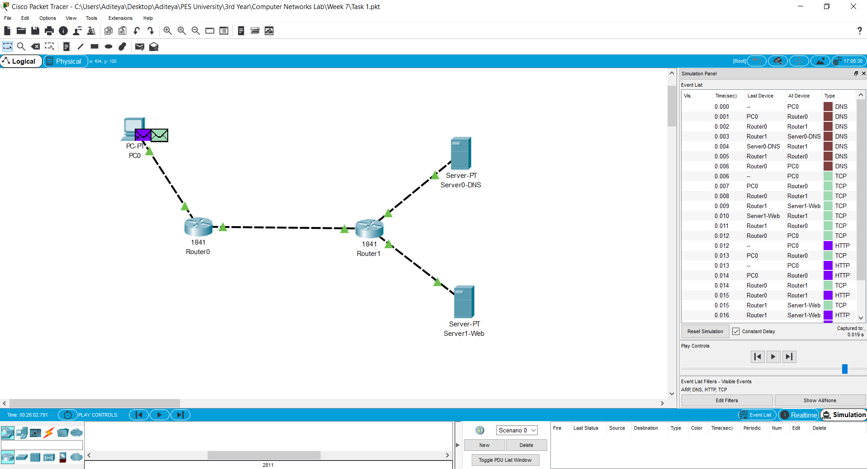

HTTP Request with DNS Service

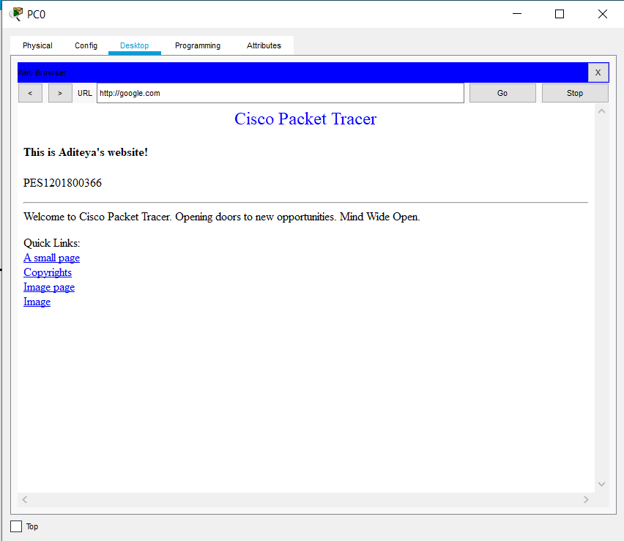

Response Received after HTTP Request

**1.2 Configuring Network and Routing Tables**

**1.2.1 End Systems**

|  |  |  |  |  |  |
| --- | --- | --- | --- | --- | --- |
| End System | Interface Name | IP Address | Subnet Mask | Gateway | DNS Server |
| PC0 | FastEthernet0 | 10.10.1.1 | 255.255.255.0 | 10.0.0.3 | 192.168.1.2 |
| Server0-DNS | FastEthernet0 | 192.168.1.2 | 255.255.255.0 | 192.168.1.1 |  |
| Server1-Web | FastEthernet0 | 192.168.2.2 | 255.255.255.0 | 192.168.2.1 |  |

**1.2.2 Routers**

|  |  |  |  |
| --- | --- | --- | --- |
| Router | Interface Name | IP Address | Subnet Mask |
| Router0 | FastEthernet0/0 | 10.10.1.2 | 255.255.255.0 |
| Router0 | FastEthernet0/1 | 10.10.2.1 | 255.255.255.0 |
| Router1 | FastEthernet0/0 | 10.10.2.2 | 255.255.255.0 |
| Router1 | FastEthernet0/1 | 192.168.1.1 | 255.255.255.0 |
| Router1 | Ethernet0/0/0 | 192.168.2.1 | 255.255.255.0 |

**1.2.3 Routing Table**

|  |  |  |
| --- | --- | --- |
| Router | Destination Network | Next Hop |
| Router0 | 192.168.1.0 | 10.10.2.2 |
| Router0 | 192.168.2.0 | 10.10.2.2 |
| Router1 | 10.10.1.0 | 10.10.2.1 |

**1.3 Observations**

The simulation’s first run takes about 0.32 seconds to complete, while the second run takes just 0.19 seconds. This difference is due to caching being performed, where the DNS Resource Record is cached and stored after the first run for the domain google.com. On the second run, the necessary DNS lookup is performed from the cache instead of the DNS server.